2. Extensive literature review
Literature review is a systematic analysis and interpretation of available information about a topic of study. It is an excellent opportunity to develop professional confidence in the field of study. The researcher should go for both conceptual literatures (concerned with concepts and theories) and empirical literatures (earlier researches done similar to the one understudy). The aim of this step is to find older and current information related to the research problem.

Why do we review literature? (Reasons)
- To know more about a problem
- To avoid duplication of information/keep your research original
- To learn the gaps in the arena of study
- To learn various methods that others used
- To forecast challenges that might be faced in the conduct of study
- To ensure that important variables that are likely to influence the problem situation are not left out of the study.

Sources of literature materials
- Published information from books, journals and reports
- Annual reports of private organizations –up-to-date estimates and projections (WHO, CDC, UNICEF)
- Electronic search engines/internet (such as Web of Science, Science Direct, SpringerLink, PubMed, Google Scholar, Semantic Scholar, Scopus)
- Gray literature (Unpublished ones e.g. Lecture notes, bulletins, newsletters, facts sheets)
- Conferences proceedings
- Media e.g. Newspapers
- Theses/dissertations
- Libraries and archives

Steps in reviewing literature
Three steps in writing review of literature
- Consider your analysis of the problem
- Organize notes based on factors
- Decide the order (you have three options)
- From broader to specific
- From global to local
- From past to present

Bias in literature review
This is distortion of available information to reflect unreal situation. Common types of bias in literature include:
- Playing down controversies & differences
- Restricting to supporting references
- Drawing far-fetched conclusions from small studies
- Using rhetoric rather than reasoning

Important tips on literature review
- Search widely
- Evaluate relevance of an information to your study
- Include information directly relevant to your study
- Mention sources for all bold statements
- Write a coherent discussion in your own words

In general
Literature review should be
- Adequate
- Relevant and
- Critical

It must answer the questions:
- How much is known about a topic?
- What is not known about the topic?
- What should be done on what is lacking?

Citation
A citation is a way of giving credit to individuals for their creative and intellectual works that you utilized to support your research. It can also be used to locate particular sources and combat plagiarism. Plagiarism is presenting someone else's work or ideas as your own, with or without their consent, by incorporating it into your work without full acknowledgement. Typically, a citation can include the author's name, date, location of the publishing company, journal title, volume number, issue number, pages or DOI (Digital Object Identifier). A citation style dictates the information necessary for a citation and how the information is ordered, as well as punctuation and other formatting.

Differences between citation styles
Different citation styles have different rules for in-text citation, reference list entries, and (sometimes) the formatting of a research work. It’s important to carefully check the rules of the style you are using.

Types of in-text citation
When you refer to a source (for example, by quoting or paraphrasing), you have to add a brief citation in the text. There are four main types of citation:

Types of in-text citation
When you refer to a source (for example, by quoting or paraphrasing), you have to add a brief citation in the text. There are three main types of citation:
- Parenthetical citation: You put the source reference in parentheses directly in your text. This usually includes the author’s last name along with the publication date or page number (Kimani, 2022 (one author), Kimani and Fatuma, 2022 (Two authors), or Kimani et al., 2022 (three or more authors)). Italicize et al.,
- Narrative citation: It is a type of citation where the author's name is used within the text of the sentence. In 2022, Kamau noted …..; According to Kamau et al. (2022), …
- Note citation: You put the source reference in a footnote or endnote.
- Numeric citation: You number each of your sources in the reference list and use the correct number when you want to cite a source (..[1].…[2]……..[3; 4]. …..[5-7]).

Number of authors
- One author = after text (Kamau, 2020); before text Kamau (2020)……..
- Two authors = after text (Kamau and Mutiso, 2020); before text Kamau and Mutiso (2020)……..
- Three authors = (Kamau, Mutiso and Fatuma, 2020) = after text (Kamau et al., 2020); before text Kamau et al. (2020)………
For example
‘Majority of first-year students in Nairobi university, Kenya, frequently abuse alcohol at 22% (69 respondents), cannabis 8% (33 respondents) and tobacco 7% (28 respondents) (Musyoka et al., 2020)”.

For reference
Musyoka, C. M., Mbwayo, A., Donovan, D., & Mathai, M. (2020). Alcohol and substance use among first-year students at the University of Nairobi, Kenya: Prevalence and patterns. PLOS one, 15(8), e0238170.

Narrative citations
The author’s surname appears in running text, and the date appears in parentheses immediately after the author’s name for a narrative citation. The author’s name can be included in the sentence in any place it makes sense.

Examples
- Kamau (2022) noted high prevalence of diabetes in Nyandarua County
- In 2022, Kamau noted high prevalence of diabetes in Nyandarua County
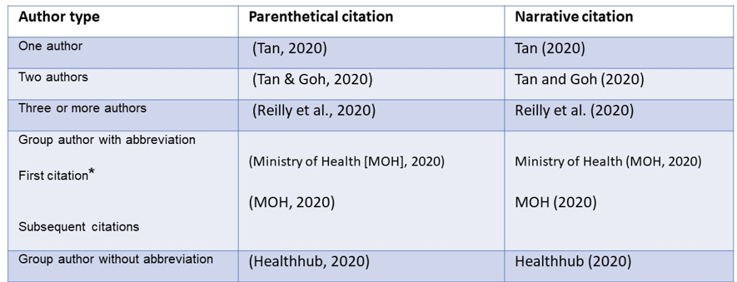
Footnotes and endnotes
Footnotes are listed at the bottom of the page on which a citation is made. A numeral is placed in the text to indicate the cited work and again at the bottom of the page in front of the footnote. A footnote lists the author, title and details of publication, in that order.
Endnotes appear on a separate page after the reference list, with the heading in bold and centered at the top. Endnotes avoid the shortcoming of footnotes but are not as quickly accessible. In texts with large numbers of citations, finding a particular note can be burdensome for some.
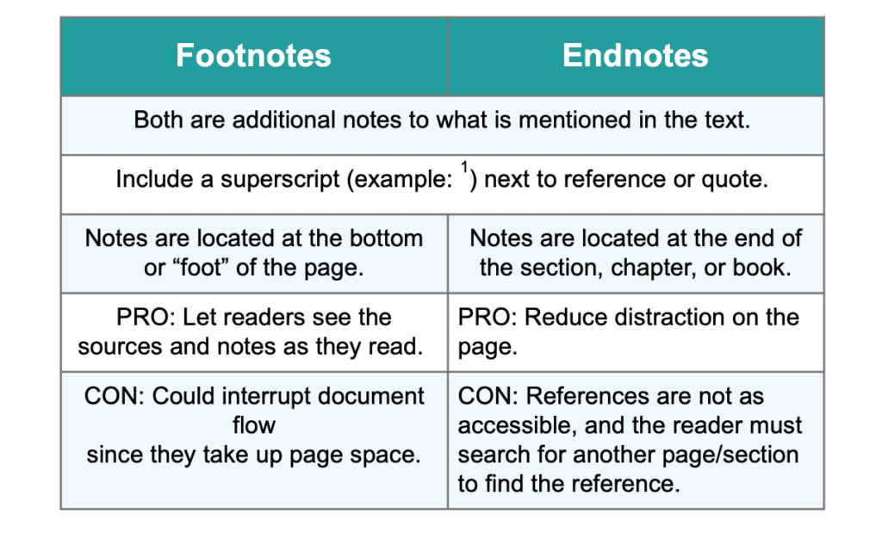

Example of footnote
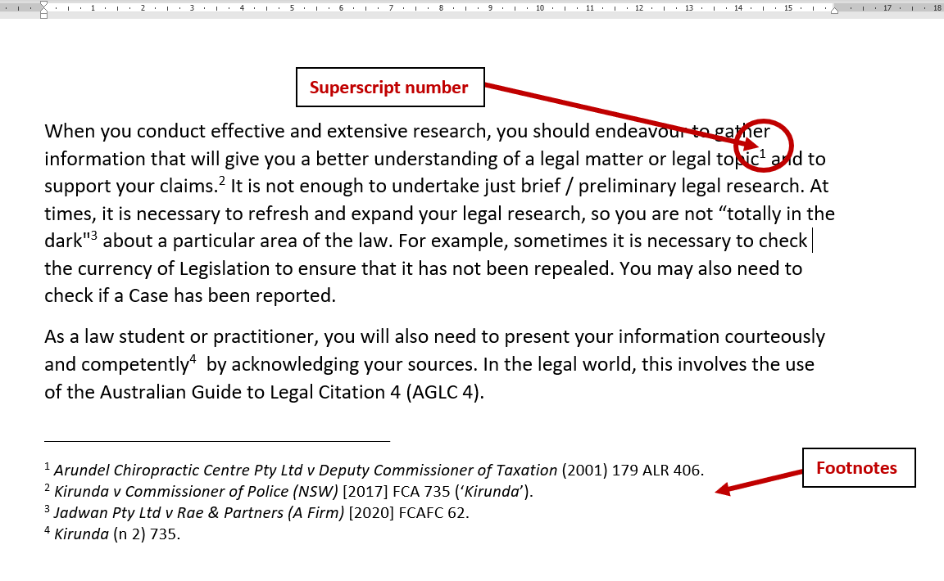
Example of endnote
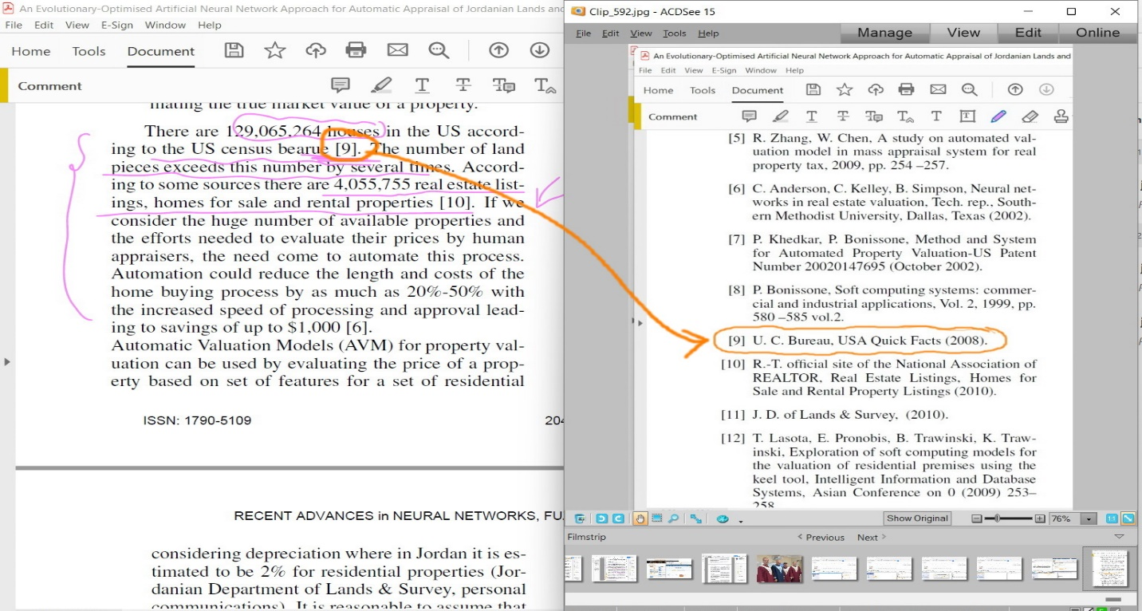

Numeric citation
- The citation is a number in superscript ^{1, 2, 3}. The first item you cite is numbered 1 and the second numbered 2 and so on.
- Sometimes you may need to refer to two documents at the same point in the text. Separate the citations with a comma ^{2,3}
- Multiple citations are treated as a range ²⁻⁴
- If you need to cite an item more than once in your document, use the same number every time. You should use the smallest number - the one used when the item is first cited in the document.
- A reference list contains the details of the material referred to in your assignment, listed in numeric order - the order in which the references appear in your document. It is required.

Types of citation styles
Citation style | Disciplines | Type of citation
- MLA (Modern Language Association) | Humanities | Parenthetical (author-page number)
- APA (American Psychology Association) | Psychology, education, social sciences | Parenthetical (author-date)
- Chicago A | History, humanities | Notes
- Chicago B | Sciences, social sciences, humanities | Parenthetical (author-date)
- Harvard | Economics | Parenthetical (author-date)
- Vancouver | Medicine | Numeric

Reference
- A reference list is arranged alphabetically by author last name.
- If a reference has no author, it is cited by title or organization (e.g WHO, 2022), and included in the alphabetical list using the first significant word of the title.
- If you have more than one item with the same author, list the items chronologically, starting with the earliest publication.
- If references from the same author share the year of publication, use lowercase alphabets at the end of the year to differentiate them both in in-text citation and in reference (e.g. Kamau et al., 2020a; Kamau et al., 2020b; Kamau et al., 2020c).
- Each reference appears on a new line.
- The reference list is double lined spaced or single line spaced (between each reference AND within each reference)
- Each item in the reference list is required to have a hanging indent.
- At the end of your paper, you include a list of all the sources you cited.
- Each entry on the list corresponds to an in-text citation, and gives the reader full publication information to easily find the source.
- Citation styles differ in the naming of this list: in APA it is the reference page, in MLA it is the works cited, and in Chicago A it is the bibliography.

There are also differences in the order of information and how you format each entry. The format often depends on the type of source (e.g. book, website, or journal article). The easiest way to create reference entries is to use a citation generator. Reference managers software’s include:
- Zotero
- Mendeley
- Endnote
- Biblioscape

One can also use google scholar to generate references

Referencing (American Psychological Association, APA, Format)
- Books (One author and two author)
Provide the author surname (s) followed by other names initiations, year of publication, title, and publisher of the book. Use the abbreviation “(Ed.)” for one editor and the abbreviation “(Eds.)” for multiple editors after the editor names.
- Kalichman, S. C. (Ed.). (2005). Positive prevention: reducing HIV transmission among people living with HIV/AIDS. Springer Science & Business Media.
- Goldin, C. D., & Katz, L. F. (2008). The race between education and technology. Belknap Press of Harvard University Press.
- Journal article (one author, two or more authors)
- Start with authors surname (s) and other names initials, followed by year of publication (parenthesis), then topic title and journal name. (A capital letter is used for key words in the journal name and topic title). The journal name and volume number are italicized, followed by the issue number in parentheses (not italicized) and then page numbers or e number. Sometimes DOI can be included.
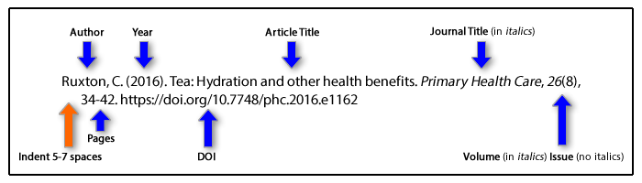
Examples
- American Diabetes Association. (2020). 15. Diabetes care in the hospital: standards of medical care in diabetes-2020. Diabetes Care, 43(1), 193-202.
- Chepkondol, G. K., Jolly, P. E., Yatich, N., Mbowe, O., & Jaoko, W. G. (2020). Types and prevalence of HIV-related opportunistic infections/conditions among HIV-positive patients attending Kenyatta National Hospital in Nairobi, Kenya. African Health Sciences, 20(2), 615-624.
- Onchonga, D., Omwoyo, J., & Nyamamba, D. (2020). Assessing the prevalence of self-medication among healthcare workers before and during the 2019 SARS-CoV-2 (COVID-19) pandemic in Kenya. Saudi Pharmaceutical Journal, 28(10), 1149-1154.

- Website
Here start with the author name, year of publication, topic title, website and date when the information was retrieved.
Example
Austerlitz, S. (2015). How long can a spinoff like ‘Better Call Saul’ last? FiveThirty Eight. http://fivethirtyeight.com/features/how-long-can-a-spinoff-like-better-call-saul-last/. Retrieved 18 April 20222

APA references arrangements

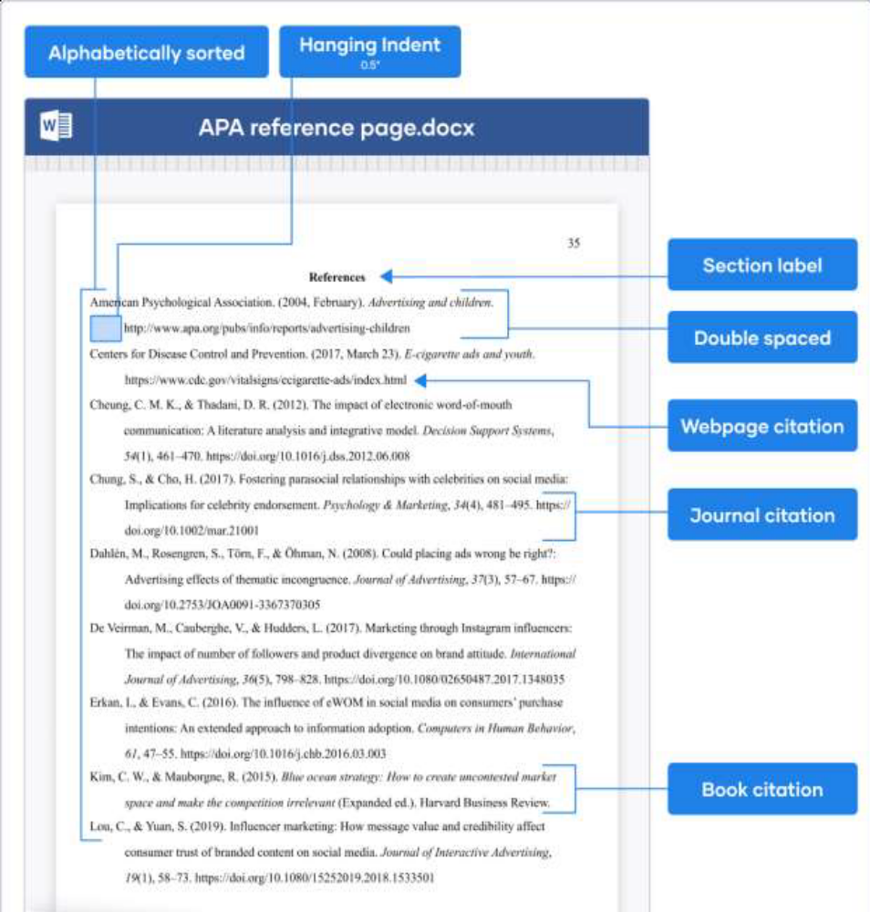

Numbering of referencing
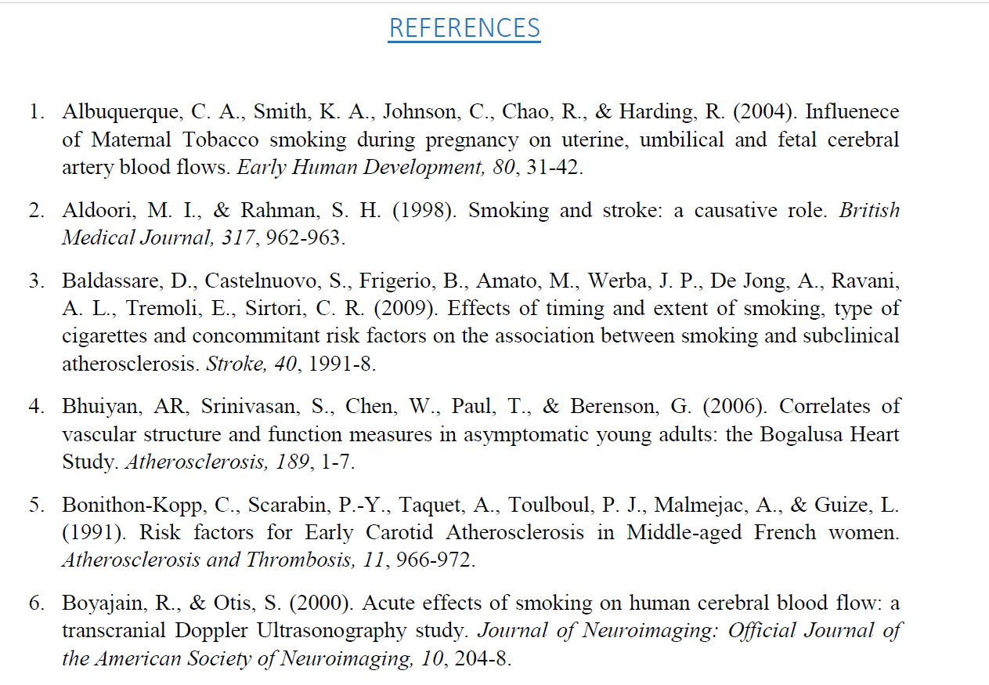

Example of journal reference using different styles
MLA
Onchonga, David, Joshua Omwoyo, and Duke Nyamamba. "Assessing the prevalence of self-medication among healthcare workers before and during the 2019 SARS-CoV-2 (COVID-19) pandemic in Kenya." Saudi Pharmaceutical Journal 28.10 (2020): 1149-1154.

APA
Onchonga, D., Omwoyo, J., & Nyamamba, D. (2020). Assessing the prevalence of self-medication among healthcare workers before and during the 2019 SARS-CoV-2 (COVID-19) pandemic in Kenya. Saudi Pharmaceutical Journal, 28(10), 1149-1154.

Chicago
Onchonga, David, Joshua Omwoyo, and Duke Nyamamba. "Assessing the prevalence of self-medication among healthcare workers before and during the 2019 SARS-CoV-2 (COVID-19) pandemic in Kenya." Saudi Pharmaceutical Journal 28, no. 10 (2020): 1149-1154.

Harvard
Onchonga, D., Omwoyo, J. and Nyamamba, D., 2020. Assessing the prevalence of self-medication among healthcare workers before and during the 2019 SARS-CoV-2 (COVID-19) pandemic in Kenya. Saudi Pharmaceutical Journal, 28(10), pp.1149-1154.

Vancouver
Onchonga D, Omwoyo J, Nyamamba D. Assessing the prevalence of self-medication among healthcare workers before and during the 2019 SARS-CoV-2 (COVID-19) pandemic in Kenya. Saudi Pharmaceutical Journal. 2020 Oct 1;28(10):1149-54.

3.Developing hypotheses, research questions and objectives
- After the selection of a research problem and review of the literature, now a researcher makes hypothesis; he talks about the purpose and main objectives of his/her research project.
- A hypothesis (plural hypotheses) is a precise, testable statement of what the researcher(s) predict will be the outcome of the study.
- One need to be careful and thorough when building your hypothesis. A minor flaw in the construction of your hypothesis could have an adverse effect on your research.
- Hypotheses cannot be proven correct from the data obtained in the experiment, instead hypotheses are either supported by the data collected or refuted by the data collected.
- Research hypotheses are the specific testable predictions made about the independent and dependent variables in the study.
- Hypothesis must be stated in precise and clearly defined terms.

Purpose of hypothesis
- Hypothesis provides direction of the study
- Ensures collection of the evidence necessary to answer the questions posed in the statement of the problem.
- Permits the researcher to understand the problem with greater clarity
- Permits data collections and provides structure for their meaningful interpretation
- It suggests which form of research design is likely to be most appropriate.
- States the purpose of the research
- Identify variables to be used in research

Features of a good hypothesis
- State clearly and briefly the expected relationship between the variables
- Must be based on sound rationale derived from theories or previous research
- Must be consistent with common sense or generally accepted truths
- It defines the selected variables in operational and measurable terms
- Must be testable and verifiable by collection and testing data
- Must be simple and concise
- Logic

Important considerations when building a research hypothesis
- State the problem that you are trying to solve
- Make sure that the hypothesis clearly defines the topic and the focus of the experiment.
- Try to write the hypothesis as an if- then statement
- If a specific action is taken, then a certain outcome is expected.
- Define the variables; a hypothesis proposes and examines the relationship between an independent variable and a dependent variable.
- The effect on the dependent variable (the idea being tested) depends on or is determined by what happens when you change the independent variable (the factor being changed).
- These are the key questions for investigating any research study. It is very important for a researcher to give answer the following questions in a proper way, if a researcher cannot answer these questions then his/her research methodology is not good and even it will be considered bias.

Types of hypothesis
- Conceptual hypothesis
- Research hypothesis
- Statistical hypothesis

Conceptual hypothesis
This is a statement about the expected relationship between theoretical concepts. These are mainly ideas that cannot be directly tested because they cannot be measured.
Example
Aerobic exercise will reduce level of anxiety

Research hypothesis
This is a statement about the expected relationship between observable or measurable events/variables. It states an expected relationship between independent and dependent variables
Example
Question: Do high alcohol content in the blood influence reaction time among drivers in Kenya.
Hypothesis: High alcohol content in the blood influence reaction time among drivers in Kenya.

Statistical hypothesis
- This hypothesis states an expected relationship between the numbers representing statistical properties of data such as mean, variance and correlation.
- This hypothesis is a guess about the value of a population parameter or about the relationship between values of two or more parameters.
- It consists of the null (H₀) and alternative (H₁) hypotheses.

Null hypothesis
- Null hypothesis states that there is no relationship exist between variables in the question or there is no difference between the variables studied. The aim of testing is to show that the hypothesis is false thereby accepting the alternative hypothesis. A null hypothesis can only be rejected, not proven. Analysts look to reject the null hypothesis because doing so is a strong conclusion. Testing null hypothesis is an element of doubt about its validity. Whatever information that is against the stated null hypothesis is captured in the alternative (alternate) hypothesis
Example:
- There is no significant difference in service delivery between private and public hospitals in Kenya

Alternate hypothesis
- Its states that there is a relationship between independent and dependent variables. It is the hypothesis that is adopted after null hypothesis is rejected.
Example:
- There is a significant difference between service delivery in private and public hospitals in Kenya.

Development of research question
A research question is a question which the research sets out to answer. In research you can either have a hypothesis or research question or sometimes both. It can be qualitative (descriptive study) or quantitative (Case study).

Importance of a research question
- Help refine broad topics into researchable variables

Characteristics of a good research question
- Relevant (relate to the topic)
- Interesting
- Focused and specific
- Researchable
- Novel/original
- Ethically acceptable
- Feasible
- Adequate technical expertise
- Affordable in time and money
- Manageable in scope

Writing a research question
Qualitative
Begin with “what” or “how” to convey an open or remerging design. It focuses on a single phenomenon or concept. Use exploratory words as non-directional rather than directional words like affect, influence, impact, determine, cause or relate. It also uses open-ended questions without reference to literature or theory
Example
- What are the causes of early pregnancies in Machakos County, Kenya?
- What drives college students to drug abusive in Kenya Medical training college?
- What are effects of early marriages in Kilifi County Kenya?
- How can the spread of HIV and AIDS minimized in Nairobi County, Kenya?

Quantitative
- A question about the relationship of variables the researcher is about to investigate
- Consider three approaches to a variable of a question
- Compare groups
- Relate variable
- Describe groups
- Measure the independent and dependent variables
Example
Does the level of education have an association with knowledge of RTIs in Nairobi, County Kenya?

Example on how to write research questions
Broad topic
Women’s health
Narrowed topic
Women smokers
Focused topic
Women and cancer
Research question
Is cigarette smoking associated with breast cancer in women?

Formulation of research objectives
Research objectives describe concisely what the research is trying to achieve. They summarize the accomplishments a researcher wishes to achieve through the project and provides direction to the study.

Types of objectives
- Estimation objectives – estimates magnitude of an event
- Association objectives – analyses factors associated with an event
- Evaluation objectives – evaluates association
Categories of objectives
- General/main objective
- Summarizes what is to be achieved by the study
- Should be clearly related to the statement of the problem
- Specific objectives
- Logically connect parts of the general objective
- Focus the study on the essentials
- Direct the design of investigations
- Orient collection, analysis and interpretation
- The specific objectives falls the order of the hypothesis or research questions

Why should research objectives be developed?
It is because research objectives:
- Focus the study
- Avoids unnecessary information
- Facilitates organizing of the study

How should we state objectives?
We do have three possible ways:
- As positive statements
- As research questions
- As a hypothesis

Criteria for setting research objectives
Research objectives should be:
- Specific/focused covering a single point
- Measurable in terms of the outcomes at the end
- Achievable/feasible – can be met by the study
- Realistic- showing some sense
- Time bound
- Operational using action-verbs such as to analyze, to investigate, to determine, to explore, to identify, to asses, to determine.
- Ordered in a logical sequence

Action-verbs Vs non-action verbs
Action-verbs
To determine To compare To verify
To calculate To describe To asses
To explore To test To establish
To identify

Non-action verbs
To appreciate To understand To show
To share To believe to study

In short the objective must be SMART
Specific
Measurable
Achievable
Realistic
Time-bound

Examples of objectives
- To determine the causes of early pregnancies in Kilifi County, Kenya.
- To evaluate factors influencing drug abusive in Kenya Medical training college student.
- To assess the causes of early pregnancies in Kenya.
- To determine the association between smoking and Lung cancer.
- To estimate the effect of diclofenac on pain.
- To determine the prevalence of Covid-19 in Kenya.

